Wynick/Tuck Gallery
401 Richmond St. W., Ground Floor
Toronto, Ontario, M5V 3A8
www.wynicktuckgallery.ca

For immediate release, April 5, 2007.

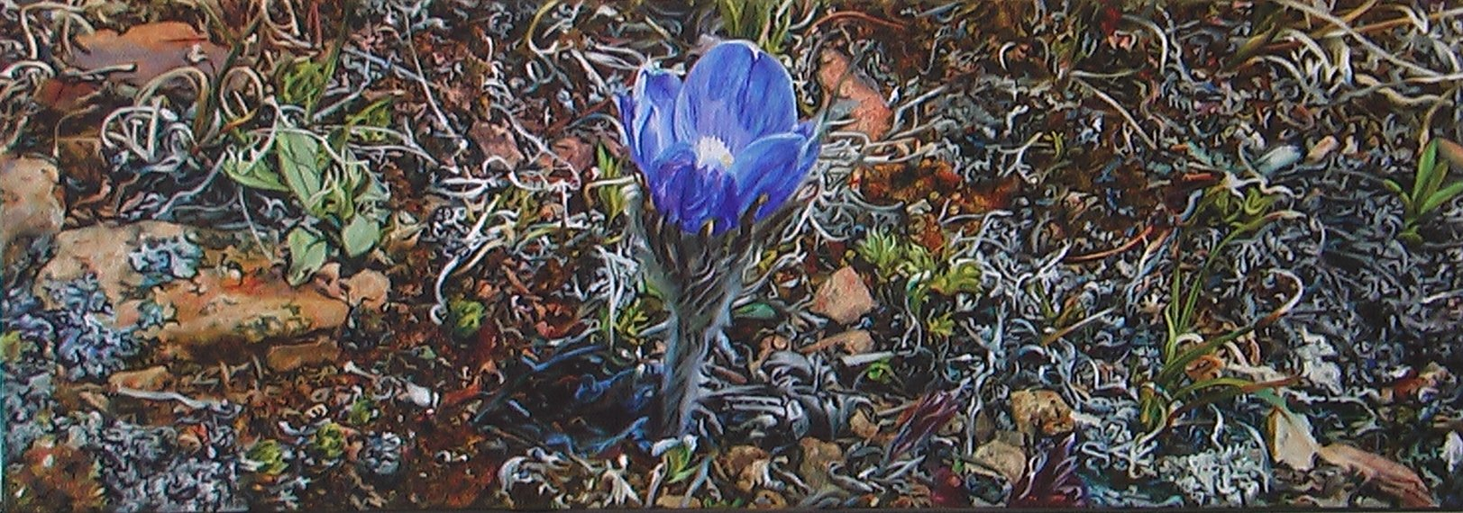
Blue Crocus, 2007, oil on canvas, 14” x 40”.

Dulcie Foo Fat
New and Selected Paintings
North Gallery
April 7 – 28, 2007
Opening, April 7
Artist Present, 2-5pm

We are pleased to announce a solo exhibition of new and selected paintings by Dulcie Foo Fat, to be presented by the Wynick/Tuck Gallery, opening on Saturday April 7, 2007. The artist will be present between 2-5 pm.

In addition to the seven new paintings in the exhibition are several works generously loaned by collectors, in order to present a mini-survey of the past decade. None of the works have previously been seen in a solo show. In all these works, Foo Fat continues to confer meaning to the inconsequential details of the ‘groundscape’ by transforming the ordinary into the extraordinary.

In her review of Dance with Minutiae, the survey exhibition of Foo Fat’s paintings curated by Monique Westra for the Whyte Museum of the Canadian Rockies, Banff, and toured to public galleries across Canada, including the McMichael Canadian Collection, Nancy Tousley states that Foo Fat’s “Painstaking style produces exquisite tapestries.”…”The artist works from [small] colour snapshot photographs, enlarging and transferring their camera-framed compositions to canvas by the grid method…. Foo Fat’s photographs give her only so much information; she must fill in the gaps where detail burns out, fades into shadows or slips out of focus.”

The work deals with …“the integration of photographic representation and her painter’s vision. Here, the photographs are more than just an image source. It’s the interplay of two kinds of vision, the translation of the one into the other, that makes this work arresting….It is the wellspring of Foo Fat’s style, which is neither trompe l’oeil nor high realism but a paradoxical form of abstraction from which realism seems to arise almost as a byproduct of method.”

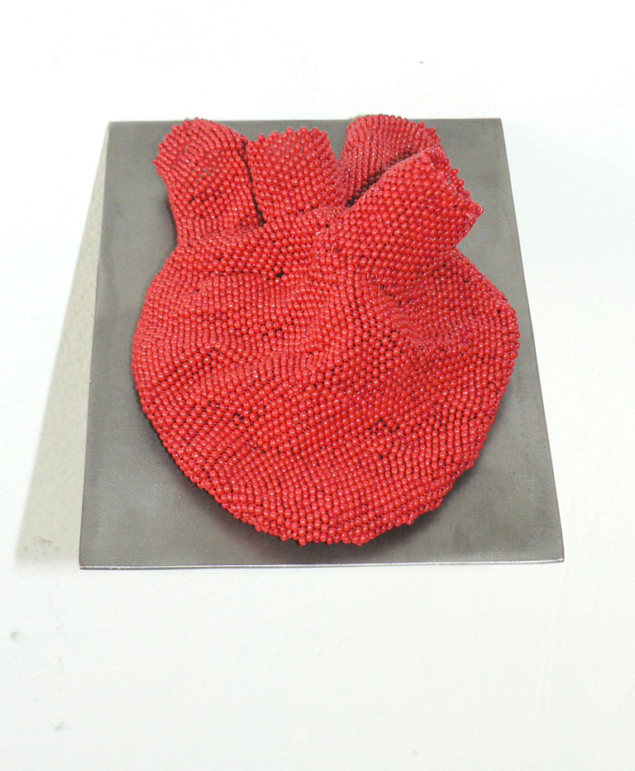
Heart, 2007, Glass beads, steel armature

Artists Present Series #4
Sarah Maloney
New Work
Project Room
April 7 – 28, 2007
Opening, April 7
Artist in attendance, 2-5pm

We are pleased to announce the fourth in our series of Artist Present exhibitions. Gallery artist Jaclyn Shoub presents the work of Sarah Maloney. Maloney explores forms and structures of the human body in sculptural textiles. In her most recent work she looks at the similarities of botanical forms to anatomical structures within the body. Themes of decoration, domesticity and a feminized body (as a garden, a place for nurturing and growth) are present in this new work.



Adam Chapman
Diagram of the Dynamics of the Physical Embodiment
South Gallery
April 7 – 28, 2007
Opening, April 7
Artist Present, 2-5pm

Diagram of the Dynamics of the Physical Embodiment of Desire, is a generative video installation about the tension within the experience of anticipation. The piece models the movement and dynamics of water rolling down a windowpane. These rules are applied to colored forms that move down the visual field of the projection. These dynamics are altered so that the discrete elements periodically form drawings of birds in flight. A tension is created between the merging of the drops as well as the forming of more legible images. Every second of the installation is uniquely generated by the rules of the system; a complete, one-hour cycle forms more than fifty drawings.

Stephen J. Shanabrook
When Anger Sings Shrapnel Flies
South Gallery
April 7 – 28, 2007
Opening, April 7
Shanabrook’s video piece, When Anger Sings Shrapnel Flies, is composed of over one hundred 35mm slide images, ranging from aerial views of pools to the casualties of a suicide bomber shredded in a blender. These torn up bits of photographic shrapnel are lit from behind and suspended in a clear liquid, where they slowly ascend in silent reverie creating random tableaux, superimpositions, and associations.
Other Openings this week-end:
Works by David Askevold and Kelly Mark are included in the exhibition Projections, a major survey of projection-based works in Canada, 1964-2007 at four University of Toronto venues, April 8 to June 17, 2007. Opening reception; Sunday, April 8 at the University of Toronto Art Centre and Justina M. Barnicke Gallery (Hart House), with artists in attendance from 4pm to 6pm., http://www.utoronto.ca/gallery

